Clausewise - Legal Document Analyzer: Your Hackathon Overview

# Clausewise - Legal Document Analyzer

PREPARED BY: Hafeez, Balu, Akhil

## Welcome to ClauseWise

Welcome to **ClauseWise**, your cutting-edge AI assistant designed to revolutionize how you interact with legal documents. In a world brimming with complex contracts, agreements, and wills, deciphering legal jargon can be a daunting and time-consuming task. ClauseWise leverages powerful Artificial Intelligence to simplify this process, making legal review incredibly easy, remarkably fast, and perfectly clear. Our mission is to empower you to quickly understand the core essence of your legal papers, even if you don't possess a legal background.

## Core Functionality: Upload and Ask Anything

At the heart of ClauseWise lies its intuitive capability to allow you to upload various document types – be it a PDF, DOCX, or plain TXT file – and then engage with them by asking specific questions. The process is simple: just drag and drop your file. Once uploaded, you can ask any question, just like in a natural conversation. For instance, if you're reviewing a 'Will' document, you could simply ask, 'What is a will?' or 'Who are the primary beneficiaries mentioned?'

ClauseWise intelligently analyzes your uploaded document and swiftly provides accurate answers directly derived from its content. This ensures you receive highly relevant information, tailored precisely to your specific legal paper, allowing you to grasp crucial details within mere seconds. No more sifting through dense pages of legalese!

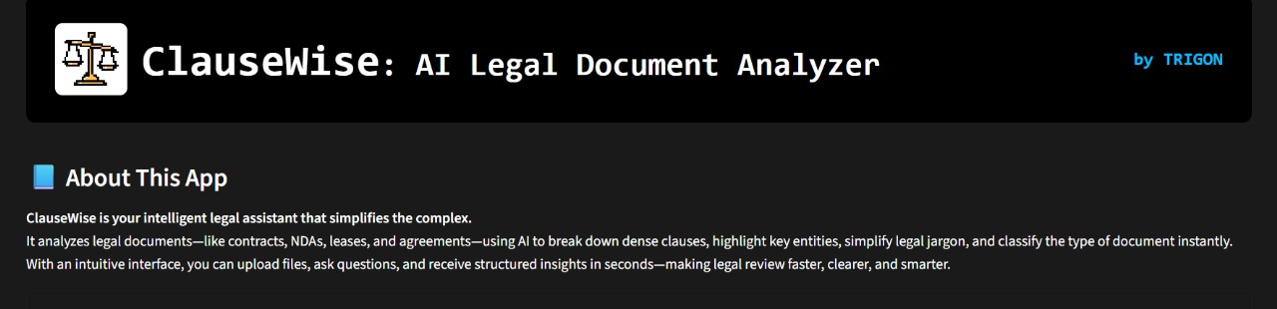

## Breaking Down the Jargon: Simplified Clauses

Legal documents are often filled with complex terminologyanyone to understand. ClauseWise excels at transforming this dense legal jargon into easily digestible, everyday language. Our system meticulously breaks down each intricate statement within your document into simpler, more comprehensible parts. This powerful feature ensures you can rapidly grasp the intended meaning without needing an extensive legal background. A complex paragraph about asset distribution, for example, can be instantly condensed into one or two clear, simple sentences, saving significant time and effort in legal revie

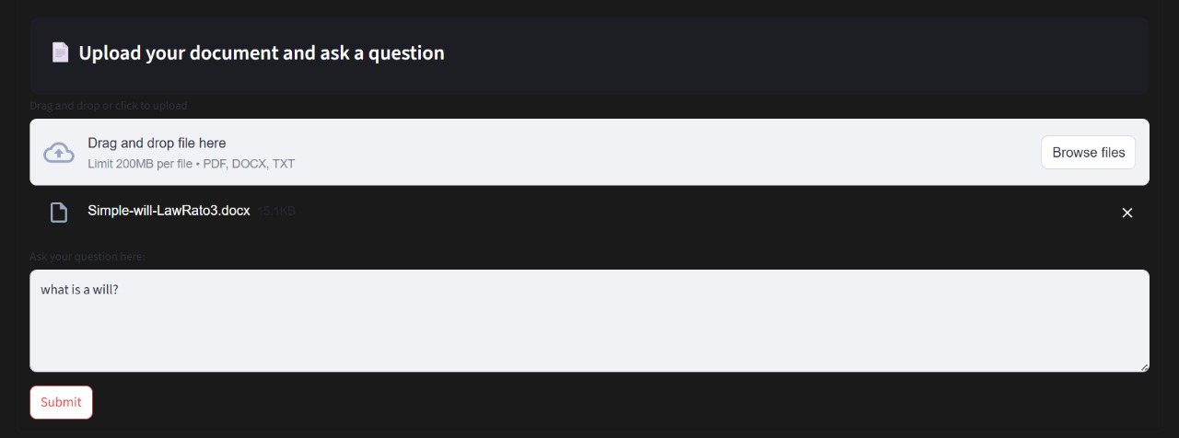

## Spotting the Key Players: Named Entity Recognition

Beyond simplifying language, ClauseWise acts like a sophisticated legal detective, diligently identifying and highlighting crucial 'named entities' embedded within your document. These entities can include the names of individuals (e.g., 'Shri'), specific organizations or companies (e.g., 'LawRato' or 'TRIGON'), or key legal terms (e.g., 'Will').

This intelligent recognition capability allows you to quickly pinpoint all the important parties and concepts, streamlining your document review process and significantly boosting accuracy by drawing your attention to the most relevant information.

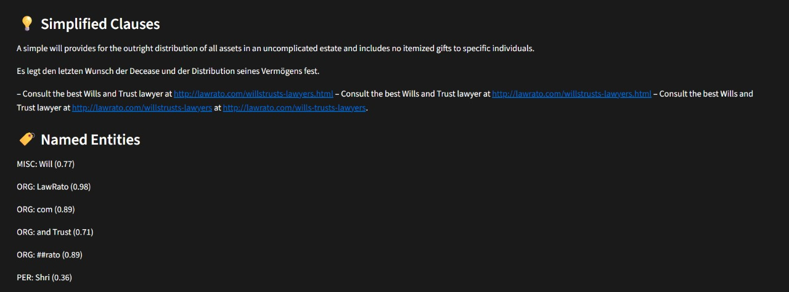

## Instant Identification: Document Type Classification

Often, when you receive a new legal file, you might not immediately know its precise nature or purpose. ClauseWise eliminates this uncertainty by automatically classifying the document type upon upload. Simply provide a file, and our AI will instantly identify if it's a 'Will', a 'Contract', a 'Non-Disclosure Agreement (NDA)', or another common legal document. This rapid classification provides immediate context, allowing you to understand the document's fundamental purpose and proceed with confidence in your review.

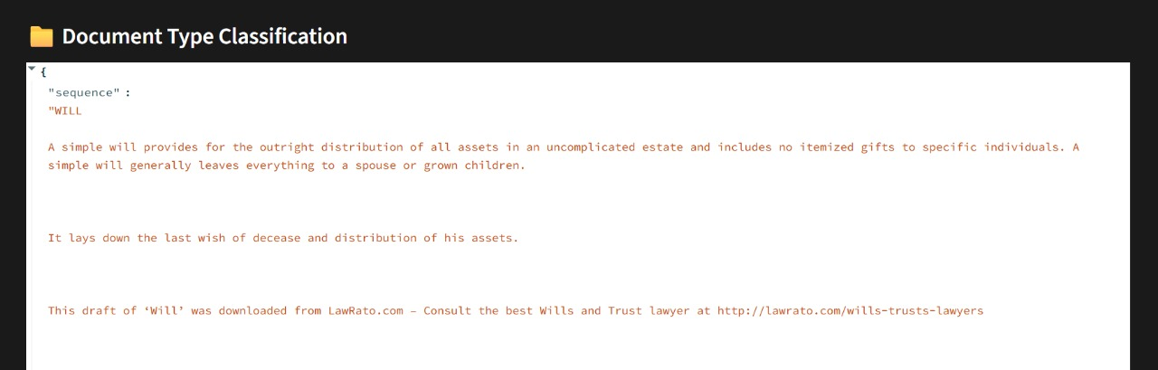

## General Legal Questions: Your Instant Knowledge Hub

ClauseWise is more than just a document analyzer; it's also a robust knowledge base for general legal queries. Even without uploading a specific document, you can tap into its vast understanding of legal principles. Have you ever wondered, 'Is a verbal agreement legally binding?' or 'What are the basic requirements for a valid contract?' ClauseWise provides instant, concise answers to these and many other fundamental legal questions. It's like having a personal, basic legal encyclopedia at your fingertips, ready to offer guidance on common legal concepts and everyday scenarios.

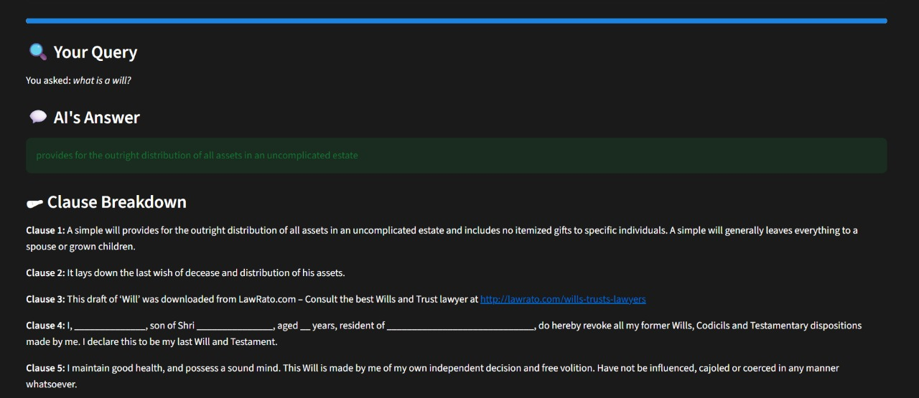

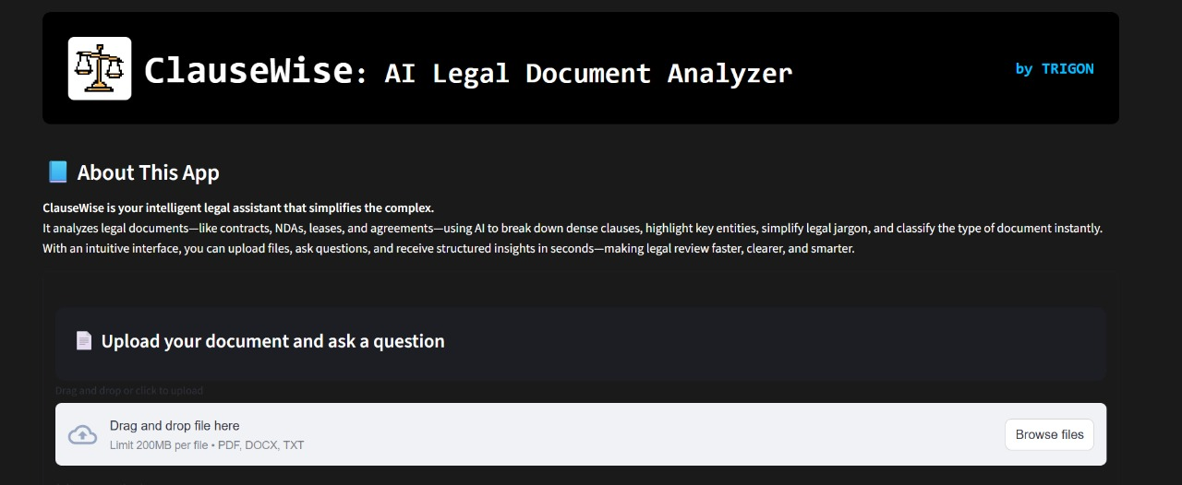

## Why ClauseWise is Perfect for Your Hackathon

For a hackathon environment where speed, efficiency, and clarity are paramount, ClauseWise is an invaluable tool. It is engineered for rapid processing, accuracy, and user-friendliness. Our application drastically reduces the time typically spent on legal document review—from potentially hours to mere seconds. This efficiency allows hackathon teams to dedicate their precious time to core development and innovation, rather than getting entangled in complex legal details. Its highly intuitive interface ensures anyone can effectively utilize it, regardless of their prior legal knowledge or experience.

## The Future of Legal Technology, Today

With advanced features like intelligent clause breakdown, precise named entity recognition, automatic document classification, and an on-demand general Q&A system, ClauseWise confidently stands at the forefront of the next generation of legal AI tools. It empowers users to navigate the often-complex world of legal documents with unprecedented confidence, clarity, and ease. We believe ClauseWise makes critical legal information accessible to everyone, fostering a smarter and faster way to interact with your essential legal papers.